**Introduction**

This report analyzes the trends in flight delays for four major airlines: American Airlines, Delta Airlines, Southwest Airlines, and United Airlines. The analysis covers the period from May 2019 to May 2024, focusing on the impact of the COVID-19 pandemic, the subsequent recovery period on airline operations, and key metrics such as on-time performance (OTP) and delay patterns. It also examines the impact of specific airports and routes on flight delays. Key questions addressed in this report include:

1. **On-Time Performance**: What percentage of flights that are on time for each airline?
2. **Comparison of Delay Causes and Number of Delayed Flights by Airline:** How do the causes of delays and the number of delayed flights differ across each airline?
3. **Airport and Route Impact**: Are delays linked to specific airport or hub?

**Overall Trends**

According to the International Air Transport Association (IATA), on-time performance (OTP) is a critical indicator of an airline's reliability and is typically defined as the percentage of flights that arrive and depart within 15 minutes of their scheduled time. The data collected and analyzed for on-time flights showed an increase during 2020 and into 2021. This improvement in OTP can be attributed to the significant reduction in flights during the COVID-19 pandemic, which minimized airport traffic, reduced airspace congestion, and streamlined processes such as security checks and boarding. With fewer flights, there was less congestion at airports and in the skies, facilitating more on-time arrivals and departures (Figure 1).

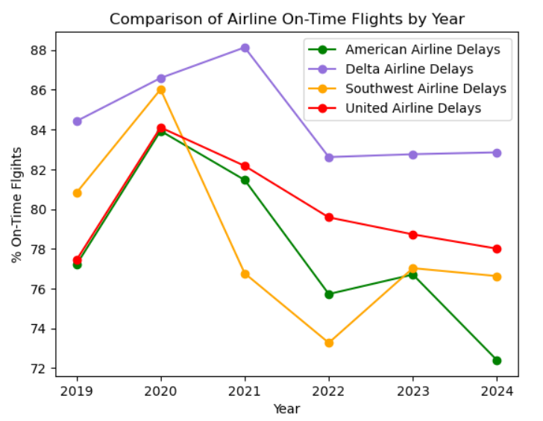

**Figure 1**

However, following 2020, there is a marked upward trend in flight delays for all airlines, reflecting the gradual recovery of flight operations as air travel resumed. The number of delays appears to peak around 2022 or 2023, suggesting that airlines faced operational challenges as they scaled back to pre-pandemic levels of activity. Delays were particularly common at the primary hubs of each airline, likely due to the high volume of traffic and congestion typical in these areas. Airports like DFW (Dallas-Fort Worth) and ATL (Atlanta) showed high total delays, with a significant portion attributed to carrier delays and late aircraft delays (Figure 2).

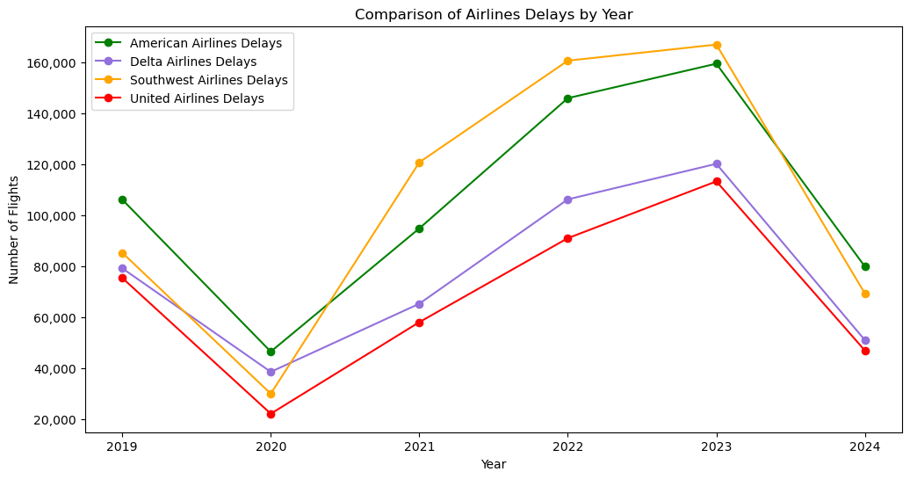

**Figure 2**

**American Airlines**

American Airlines exhibits a sharp decline in delays in 2020, consistent with the overall trend observed across the industry. From 2021 onwards, there is a steady increase in delays, reaching a peak in 2023. This pattern indicates that as flight operations recovered, American Airlines experienced growing operational delays, potentially due to increased flight volumes and associated logistical challenges. The steady increase in delays through 2023 suggests ongoing adjustments in managing flight schedules and crew availability post-pandemic. Delays at American Airlines' primary hubs, such as DFW, were particularly high, driven by carrier and late aircraft delays, highlighting areas for operational improvements (Figure 3).

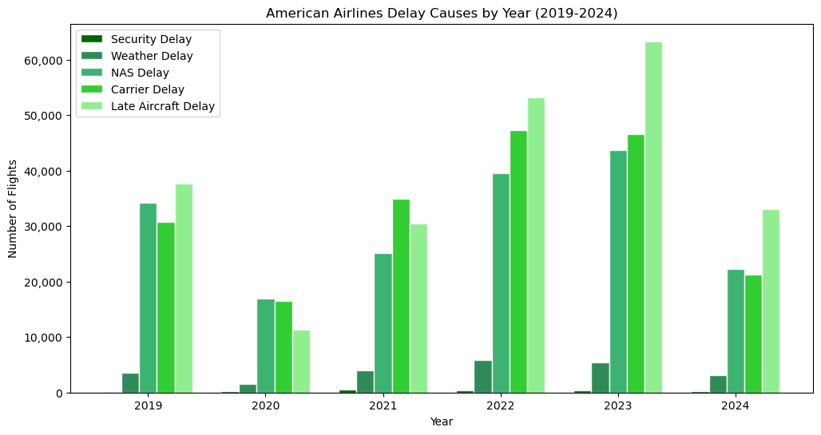

**Figure 3**

**Delta Airlines**

Delta Airlines demonstrates a similar trend to American Airlines, with the lowest number of delays recorded in 2020 due to the pandemic. However, unlike American Airlines, Delta maintains a relatively stable number of delays from 2021 to 2023, with only gradual increases. This stability indicates that Delta Airlines may have managed its recovery phase more effectively, maintaining consistent performance during the period of increased flight activities. Despite the challenges faced by the industry, Delta's approach to managing flight operations and delays appears to have been more controlled compared to its peers. Airports like ATL, a major hub for Delta, also experienced significant weather delays, indicating vulnerabilities to adverse weather conditions (Figure 4).

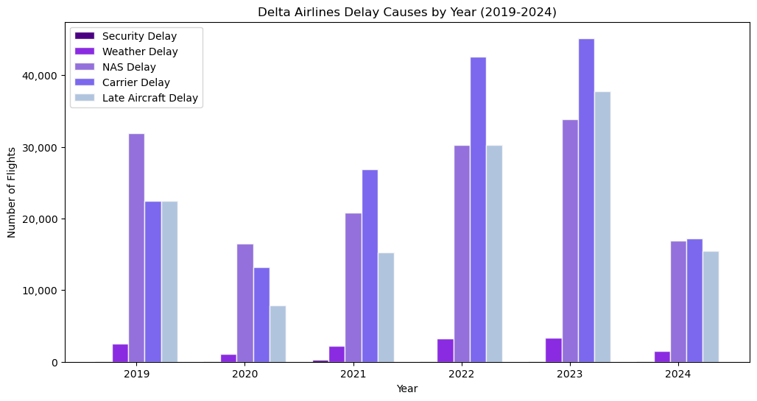

**Figure 4**

**Southwest Airlines**

Southwest Airlines presents a distinct pattern with a noticeable peak in delays in 2023. This peak suggests that Southwest encountered significant operational or external issues that led to a substantial increase in delays that year. The data indicates that Southwest Airlines struggled more with delays compared to the other airlines, particularly in 2023, highlighting potential areas for operational improvements. The higher delays could be attributed to factors such as staffing shortages, increased flight frequencies, or other logistical challenges unique to Southwest during this period. Southwest's primary hubs showed high delays, particularly in NAS delays at airports like DEN (Denver), indicating significant air traffic control issues or airspace congestion (Figure 5).

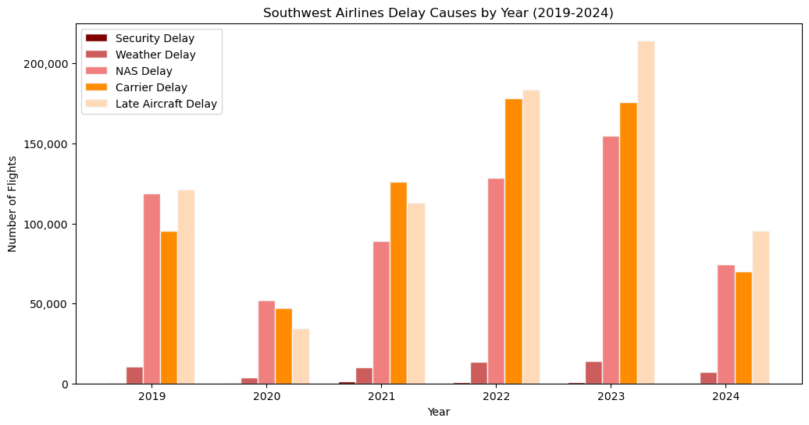

**Figure 5**

**United Airlines**

United Airlines follows the general industry trend of a decrease in delays in 2020, followed by a steady increase through 2023. However, United Airlines shows the least variability in the number of delays compared to the other airlines. This lower variability suggests that United Airlines managed to maintain a more stable operation during the recovery phase, possibly due to better planning and execution of flight schedules and resource allocation. The steady increase in delays through 2023 reflects the industry's broader challenges but also indicates that United Airlines was relatively successful in managing these disruptions. Airports like ORD (Chicago O'Hare), a significant hub for United, experienced high NAS delays, pointing to air traffic control issues as a major contributor to delays (Figure 6).

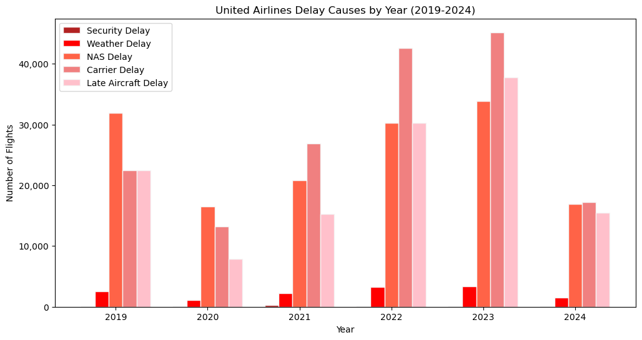

**Figure 6**

**Causes of Delays by Airline**

Analyzing the causes of delays reveals that **carrier delays** and **late aircraft delays** are significant contributors to overall delays for all airlines (Figure 7), with notable differences in the magnitude and timing of these delays. Southwest Airlines consistently shows the highest carrier delays, peaking between 2021 and 2023, indicating substantial operational challenges. American Airlines and Delta Airlines also show increases in carrier delays, but to a lesser extent, suggesting different levels of operational efficiency. United Airlines consistently has lower carrier delays, indicating effective management of carrier-specific issues.

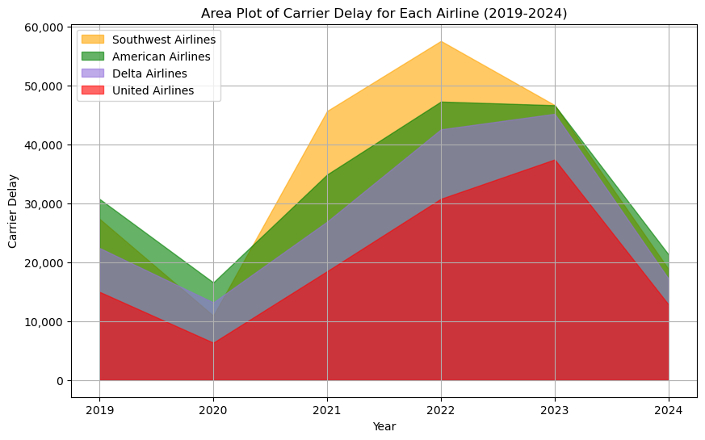

**Figure 7**

In terms of **late aircraft delays**, Southwest Airlines again leads, particularly peaking sharply from 2021 to 2023, highlighting ongoing challenges with aircraft scheduling and turnaround times. American Airlines shows a substantial increase in late aircraft delays, peaking in 2023, while Delta Airlines and United Airlines have relatively lower late aircraft delays, reflecting broader industry challenges.

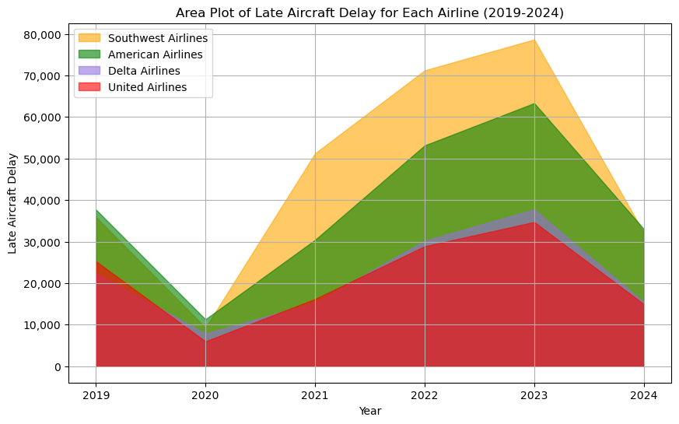

**Figure 8**

**NAS delays** (National Aviation System delays) also vary among the airlines, with Southwest Airlines showing a small rise from 2020 to 2023, indicating difficulties in managing delays caused by air traffic control and other system-wide issues. American Airlines shows a notable increase in NAS delays compared to other airlines. Peaking around 2022-2023. Delta Airlines and United Airlines have the least NAS delays after2021, suggesting better handling of system-wide operational disruptions (Figure 9).

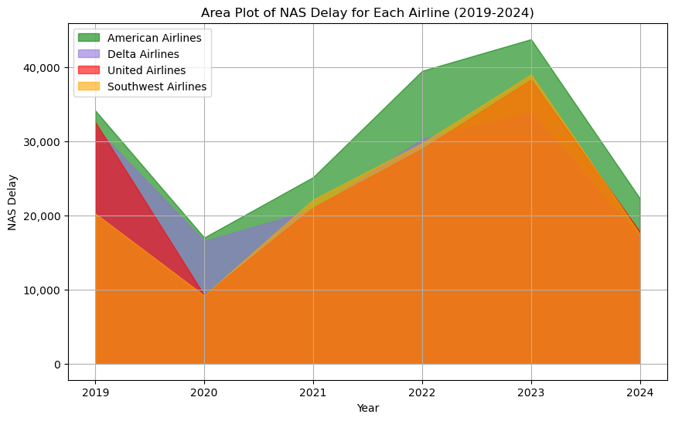

**Figure 8**

**Security delays** and **weather delays** are less prominent but still significant in certain contexts. American Airlines shows the most substantial security delays, particularly peaking in 2021, while United Airlines consistently has the lowest security delays. Regarding weather delays, American Airlines experiences the highest levels, peaking in 2022, indicating vulnerability to weather-related disruptions. Southwest Airlines follows with moderate weather delays, while Delta Airlines and United Airlines show lower levels, indicating better operational strategies to mitigate weather impacts (Figure 9 and 10).

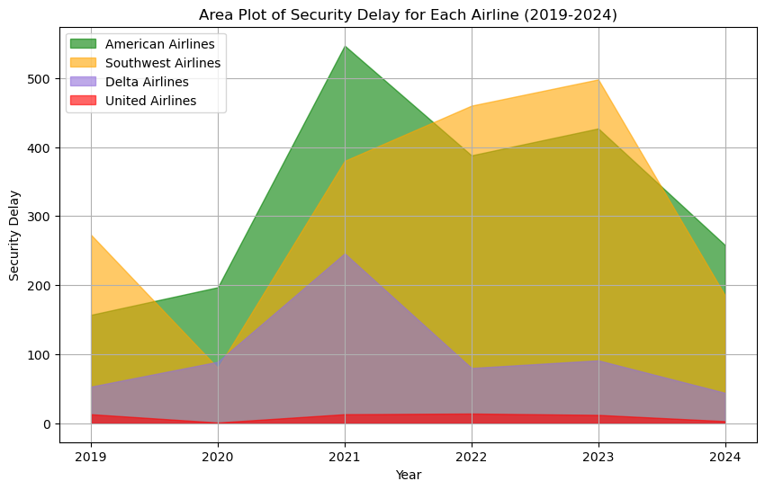

**Figure 9**

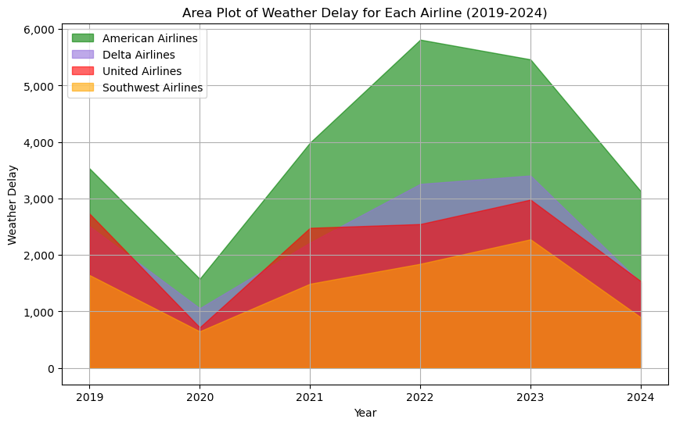

**Figure 10**

**Conclusion**

The analysis of flight delays for these major airlines from 2020 to 2023 highlights the substantial impact of the COVID-19 pandemic on flight operations and the subsequent recovery phase's challenges. The data indicates that delays are more common at the primary hubs of each airline, likely due to the high volume of traffic and congestion typical in these areas. NAS delays were particularly prevalent at airports like DEN (Denver) and ORD (Chicago O'Hare), indicating that air traffic control issues or airspace congestion are major contributors to delays at these locations. Understanding the primary delay causes allows airports to implement targeted improvements, such as enhancing air traffic management systems at airports with high NAS delays.

Southwest Airlines generally experiences higher delays across most categories, particularly in carrier and late aircraft delays, indicating significant operational challenges. American Airlines shows a broad range of delays, especially in weather and security categories, pointing to specific areas needing improvement. Delta Airlines and United Airlines generally perform better with lower delays across most categories, suggesting effective management of operational disruptions.